Predicting Adoption Outcomes for Dogs and Cats

Heather L Stukenbroeker
Western Governors University

Contents
A.Project Highlights 4
A.1 Research Question 4
A.2 Project Scope 4
A.3 Overview of Solutions: Tools and Methodologies 4
B. Project Execution 5
B.1 Project Plan 5
B.2 Project Planning Methodology 5
B.3 Project Timeline and Milestones 6
C. Data Collection Process 6
C.1 Advantages and Limitations of Data Set 7
D. Data Extraction and Preparation 7
D. 1 Data Extraction 7
D.2 Data Preparation 7
E. Data Analysis Process 9
E.1 Data Analysis Methods 9
E.2 Advantages and Limitations of Tools and Techniques 10
E.3 Application of Analytical Methods 11
F Data Analysis Results 13
F.1 Statistical Significance 13
F.2 Practical Significance 15
F.3 Overall Success 16
G. Conclusion 17
G.1 Summary of Conclusions 17
G.2 Effective Storytelling 18
G.3 Recommended Courses of Action 26
Recommendation 1 — Implement a Length of Stay Early Intervention Program 26
Recommendation 2 — Develop Targeted Adoption Initiatives for High-Risk Animal Profiles 26
H Panopto Presentation 27
References 28
Appendix A 29
Project Code 29
Appendix B 30
Data Sources 30

Project Highlights

A.1 Research Question
Animal shelters across the country and around the world face significant challenges in identifying which animals are most at risk of poor outcomes before those poor outcomes occur. This project aims to address the question: Which animal characteristics, including species, age, breed, color, sex, neuter status, intake type, intake condition, and length of stay, most strongly predict whether a cat or dog that is admitted to the Austin Animal Center will be adopted, returned to the owner, transferred, or face euthanasia? Answering this question will help the shelter administrators prioritize limited resources towards at-risk animals and improve the shelter’s live-release rate.

A.2 Project Scope
The objective of this project was to examine which characteristics would strongly predict whether a dog or a cat would be adopted from the Austin Animal Center. The scope of this project included the collection, cleaning, and preparation of the Austin Animal Center Intakes and Outcomes datasets obtained from the City of Austin Open Data Portal. These datasets cover intake records for dogs and cats from October 2013 through May 2025. This project also includes exploratory data analysis, eight visualizations, development and evaluation of a random forest classification model, feature importance analysis, and the findings and recommendations.
This project did not include animals other than dogs and cats, data from shelters other than the Austin Animal Center, real-time model deployment, or a cost-benefit analysis of shelter interventions.

A.3 Overview of Solutions: Tools and Methodologies
The goal of this project was to find the key characteristics associated with animal adoption. By identifying these characteristics, the shelter can identify which animals are more likely to be adopted quickly and which animals will need more intervention. The analytical solution developed in this project followed the CRISP-DM methodology's six steps to keep the project organized and well structured: Business Understanding, Data Understanding, Data Preparation, Modeling, Evaluation, and Deployment. Python 3.12 was the primary programming language used in Visual Studio Code, and a Jupyter Notebook was used for its storytelling capabilities. The pandas library was used for data cleaning and preparation. Scikit-learn was used to build and evaluate the random forest classification model. Finally, matplotlib and seaborn were used to produce all visualizations in this report. The final cleaned dataset contained 178,122 records and nine predictor variables. The random forest classifier achieved an overall accuracy of 76% in predicting adoption across the four outcome categories. Model performance was evaluated using a classification report that included precision, recall, and F1-score for each outcome category. A confusion matrix was also used to identify where the model made correct predictions and incorrect predictions across the outcome categories. Feature importance scores were also extracted from the trained model to identify which animal characteristics most strongly influenced outcome predictions.

B. Project Execution

B.1 Project Plan
This project followed the plan outlined in Task 2, Section B1. The single goal, along with its four objectives and five deliverables, was completed as planned. The cleaned and joined dataset was successfully produced; exploratory data analysis was conducted using eight visualizations; the random forest classification model was trained and evaluated; feature importance scores were extracted; and the findings report was completed. No significant deviations from the original project plan occurred.

Task 2, B.1 Goals, Objectives, and Deliverables
- Goal 1: Develop a classification model that predicts adoption outcomes for dogs and cats at the Austin Animal Center using historical intake data to support data-driven resource allocation decisions.
  - Objective 1.1: Collect, clean, and prepare the Austin Animal Center Intakes and Outcome datasets for analysis.
    - Deliverable 1.1.1: A clean and joined dataset combining intake and outcome records for dogs and cats, free of missing values and ready for modeling.
  - Objective 1.2: Conduct exploratory data analysis to identify patterns and relationships between animal characteristics and adoption outcomes.
    - Deliverable 1.2.1: A series of visualizations illustrating outcome distributions by species, breed, age, color, and intake type.
  - Objective 1.3: Build and evaluate a random forest classification model to predict adoption outcomes.
    - Deliverable 1.3.1: A trained random forest classifier with documented accuracy, precision, recall, and F1-score metrics.
    - Deliverable 1.3.2: A feature importance chart identifying which animal characteristics most strongly predict adoption outcomes.
  - Objective 1.4: Communicate findings and recommendations to shelter administrators.
    - Deliverable 1.4.1: A written report summarizing the methodology, findings, graphs, and actionable recommendations for shelter staff.

B.2 Project Planning Methodology
This project followed the Cross-Industry Standard Process for Data Mining (CRISP-DM), the de facto standard and an industry-independent process model for data mining projects (Schroer, Kruse, & Gomez, 2021) . CRISP-DM organizes the work into six phases: Business Understanding, Data Understanding, Data Preparation, Modeling, Evaluation, and Deployment. Each phase of this project maps directly to one of these CRISP-DM phases.
Business Understanding – This phase involves defining the project objectives and understanding the organizational need. For this project, the business understanding phase was completed through the identification of the research question, the literature review, and the development of the project proposal. The organizational need, helping shelter administrators identify at-risk animals earlier in order to improve live release rates, establishes the foundation for the remaining phases.
Data Understanding – This phase involves collecting and exploring the data to identify quality issues and initial patterns. For this project, the Austin Animal Center Intakes and Outcomes datasets were downloaded from the City of Austin Open Data Portal and examined for structure, completeness, and relevance. Exploratory data analysis, including summary statistics and visualizations, was conducted to understand distributions and relationships within the data.
Data Preparation -- This phase involves cleaning, transforming, and preparing the data for modeling. For this project, data preparation included joining the intake and outcome datasets on Animal ID, filtering dogs and cats, handling missing values, converting age to a numeric format, calculating the length of stay, extracting the intake month, and encoding categorical variables using label encoding.
Modeling – This phase involves selecting and applying analytical techniques to prepare the data. For this project, a random forest classification model was developed in Python using the scikit-learn library to predict adoption outcomes across four categories: Adopted, Transferred, Returned to Owner, and Other. The dataset was split into 80% for training and 20% for testing using stratified sampling to maintain balanced class representation.
Evaluation – This phase involves assessing the model’s performance against the project's objectives. For this project, the model was evaluated using a classification report that included precision, recall, and F1-score for each outcome category, along with a confusion matrix to identify correct and incorrect predictions. Overall model accuracy was used as the primary benchmark for success.
Deployment – This phase involves communicating results and making them usable. For this project, the deployment phase consists of a written report that summarizes the methodology, presents the findings, and provides actionable recommendations for shelter administrators based on the model’s feature importance results.

B.3 Project Timeline and Milestones
This project was completed within the timeline established in Task 2, Section B4, with all major milestones completed between March 26, 2026, and April 10, 2026. Reviews, final revision, and submission ran two days ahead of schedule. The data collection and preparation phase took slightly longer than the three days originally planned due to the additional data quality issues described above, particularly the discovery that the two newer 2025 datasets used a different column structure than the historical datasets and had to be excluded from the analysis. This step added approximately one additional day to the data preparation phase but did not affect the overall project completion date. All remaining milestones were completed on schedule.

C. Data Collection Process
The data selection and collection process for this project was completed as planned, and I encountered no significant deviations. The Austin Animal Center Intakes and Outcomes datasets were downloaded from the City of Austin Open Data Portal in a CSV format.
A key obstacle I encountered during data collection was discovering that the Austin Animal Center had migrated to a new database system in 2025. This migration resulted in two separate datasets for intakes and outcomes: one covering October 2013 through May 5, 2025, and another covering May 5, 2025, to the present day. The newer system uses a different column structure than the historical datasets, making them incompatible for direct merging without extensive additional processing. After evaluating the trade-offs, I decided to exclude the newer system datasets and use only the historical datasets, which provided sufficient data for modeling.
No unplanned data governance issues were encountered during the project. All data was handled in accordance with the governance precautions described in the original project plan, including storing the original downloaded files without modification, performing all cleaning steps on copies within the Python environment, and removing all animal names from the working data.

C.1 Advantages and Limitations of the Dataset
The Austin Animal Center datasets offered several significant advantages for this project. The key advantage of this dataset was its size. After cleaning and preparation, the final analytical dataset contained 178,122 records spanning more than eleven years of shelter operations. This volume of data provided the random forest classifier with sufficient records across all four outcome categories, allowing it to identify meaningful patterns and produce reliable predictions. Public availability of the data was another advantage, as it made the dataset more suitable for reproducible academic research and analysis. The final advantage was the relational structure of the two datasets, which were designed to be joined on a shared Animal ID field, allowing intake characteristics and outcomes to be linked at the individual-animal level.
The primary limitation of the dataset is that it captured only the characteristics of animals at the time of intake and does not include behavioral assessments, medical history beyond intake condition, or post-intake observations that might have improved predictive accuracy. A second limitation was that breed designations were assigned by shelter staff based on visual assessment rather than genetic testing, potentially introducing inconsistencies in breed labeling, particularly for mixed-breed dogs. Research has shown that shelter staff are often inconsistent in their breed designations, which may affect the reliability of breed as a predictor variable (Powell, et al., 2021).

D. Data Extraction and Preparation

D. 1 Data Extraction
The data extraction process involved downloading two CSV files from the City of Austin Open Data Portal and loading them into Python using the pandas library. The Austin Animal Center Intakes and Outcomes datasets were each read into separate pandas DataFrames (df) using the pd.read_csv() function.

D.2 Data Preparation
Following extraction, the combined dataset underwent several preparation steps to produce a clean, model-ready analytical dataset. The dataset was first filtered to include only dogs and cats by using .isin() function applied to the Animal Type column, removing records for all other species. This reduced the dataset to 163,932 intake records and 163,904 outcome records prior to joining.
The two DataFrames were joined on the shared Animal ID field using an inner join via the pd.merge() function with the parameter how=’inner’, which retained only records that contained both an intake and a corresponding outcome. Records without a matching outcome were excluded because they could not contribute meaningful information to the classification model. This join produced a combined dataset of 211,295 records. The inner join was appropriate for this project because the research question required both intake characteristics and outcomes for each animal.
Duplicate and unnecessary columns created by the inner join were identified and removed using df.drop() function. Columns that appeared in both datasets with the same name received an _x suffix for the intake version and a _y suffix for the outcome version. The intake versions were retained, and the duplicate outcome columns were dropped. All columns were renamed for clarity using the df.rename() function, with DateTime_x renamed to Intake DateTime and DateTime_y renamed to Outcome DateTime.
Missing values were assessed across all columns using the df.isnull().sum() function. The Name, Outcome Subtype, Outcome Type, Sex upon Intake, Sex upon Outcome, and Age upon Outcome columns were dropped entirely due to high proportions of missing values and limited predictive relevance. Remaining rows with missing values in critical columns were removed using the df.dropna() function.
The Age upon Intake column was converted from a string format, such as "7 years", to a standardized numeric value measured in days using a custom Python function applied via the .apply() method. Records containing negative age values resulting from data entry errors were identified and removed using boolean indexing.
The Intake DateTime and Outcome DateTime columns were converted from string format to Python datetime objects using the pd.to_datetime() function. The Outcome DateTime column contained timezone offset information that required the utc=True parameter and subsequent timezone removal using the .dt.tz_localize(None) method before the two columns could be used together in calculations.
Length of stay was calculated as the number of days between Intake DateTime and Outcome DateTime for each record using the .dt.days attribute. Records with negative length-of-stay values, resulting from mismatches between intake and outcome records for animals with multiple shelter visits, were removed. Records with a length of stay greater than 365 days were also removed as outliers, as they were not representative of typical shelter stays.
The outcomes dataset contained 11 original outcome categories, which were combined into four meaningful groups for modeling — Adopted, Transferred, Returned to Owner, and Other — using a mapping dictionary applied via the df[‘Outcome Type’].map() function. This consolidation improved the model's ability to learn meaningful patterns from the data.
An Intake Month feature was engineered by extracting the month number from the Intake DateTime column using the .dt.month attribute, to capture seasonal patterns in shelter intake and adoption activity.
All categorical predictor variables — Animal Type, Intake Type, Intake Condition, Sex upon Intake, Breed, and Color — were encoded as numeric values using scikit-learn's LabelEncoder with le.fit_transform() method. After all preparation steps were completed, the final analytical dataset contained 178,122 records and nine predictor variables ready for modeling.

E. Data Analysis Process

E.1 Data Analysis Methods
Two primary analytical methods were used in this project: exploratory data analysis and supervised machine learning classification modeling.
Exploratory Data Analysis

Exploratory data analysis (EDA) was conducted prior to modeling to examine variable distributions, identify patterns and relationships among animal characteristics and adoption outcomes, and inform decisions on feature selection and outcome consolidation. EDA was performed using the pandas library for summary statistics and the matplotlib and seaborn libraries for visualizations. Eight charts were produced during this phase to examine outcome distributions, species differences, intake type effects, length-of-stay patterns, intake condition effects, and breed-level outcome differences. EDA was an appropriate method for this project because it provided the foundational understanding necessary to support modeling decisions and ensured that the patterns identified by the model were grounded in observable data trends.
Random Forest Classification

A random forest classification model was developed to predict adoption outcomes for dogs and cats based on nine animal characteristics at intake. Random forests are supervised machine learning methods that build an ensemble of decision trees during training and combine their predictions by majority vote to produce a final classification. This method was appropriate for this project because the outcome variable contained four discrete categories rather than a continuous value, making classification the correct modeling approach. Random forests can also handle mixed data types, they are resistant to overfitting, and they produce interpretable feature importance scores that directly address the research question by identifying which animal characteristics most strongly predict adoption outcomes.

E.2 Advantages and Limitations of Tools and Techniques
Python and pandas

The key advantage of using Python and pandas was the availability of a comprehensive data science environment that enabled data cleaning, feature engineering, modeling, and visualization. Python is also open source and freely available, which supports reproducibility. A limitation of Python is that it requires coding knowledge and familiarity with library syntax, creating a higher barrier to entry than point-and-click tools such as Tableau or Excel. In addition, some pandas operations on large datasets can be memory-intensive, although this did not present a practical issue for the dataset used in this project.
scikit-learn
The key advantage of using scikit-learn is its comprehensive implementation of machine learning algorithms (random forest classifier), the built-in tools for train-test splitting, label encoding, and model evaluation metrics. A limitation of scikit-learn's random forest implementation is that the trained model is not easily interpretable at the individual tree level, which makes it difficult to explain specific predictions to non-technical audiences, such as shelter staff, without additional visualization tools.
matplotlib and seaborn

The key advantage of matplotlib and seaborn was the ability to produce a wide variety of publication-quality charts directly from the pandas DataFrames with minimal code. A limitation is that matplotlib charts often require manual formatting to achieve professional presentation quality, and default styling can appear plain without additional customization.
Visual Studio Code and Jupyter Notebook

The key advantage of this environment was that code, output, and markdown documentation could be presented together in a single readable document, making the analysis transparent, reproducible, and easy to follow. A limitation is that Jupyter Notebooks can become difficult to manage as they grow longer, and running cells out of order can cause variable conflicts that are difficult to debug.

E.3 Application of Analytical Methods
The following steps describe how the analytical methods were applied to the data in this project:
Step 1 — Data loading and filtering
The Austin Animal Center Intakes and Outcomes CSV files were loaded into Python as separate pandas DataFrames using pd.read_csv(). Both DataFrames were filtered to include only dogs and cats using the .isin() function applied to the Animal Type column.
Step 2 — Data joining
The filtered intake and outcome DataFrames were joined on the shared Animal ID field using pd.merge() with how='inner' to retain only records with both intake and outcome information. This join produced a combined dataset of 211,295 records.
Step 3 — Data cleaning
Duplicate columns from the merge were dropped using df.drop() and renamed using df.rename(). Missing values were assessed using df.isnull().sum() and addressed by dropping irrelevant columns and removing rows with missing values in critical variables using df.dropna(). Negative age values and extreme length-of-stay outliers were removed using boolean indexing.
Step 4 — Feature engineering
The Age upon Intake column was converted from string format to numeric days using a custom function applied via .apply(). Length of stay was calculated by subtracting Intake DateTime from Outcome DateTime using the .dt.days attribute. Intake Month was extracted from Intake DateTime using the .dt.month attribute. The eleven original outcome categories were consolidated into four groups using .map().
Step 5 — Exploratory data analysis
Eight visualizations were produced using matplotlib and seaborn to examine outcome distributions, species differences, intake type and condition effects, length-of-stay patterns by outcome category and species, breed-level outcome differences, and feature importance. These charts informed the final feature selection decisions and established the analytical context for the model results.
Step 6 — Feature encoding
Six categorical predictor variables were encoded as numeric values using scikit-learn's LabelEncoder with le.fit_transform() to meet the requirements of the random forest algorithm, which required all input features to be numeric.
Step 7 — Train-test split
The prepared dataset was split into 80% training and 20% testing sets using scikit-learn's train_test_split() function with stratify=y to ensure balanced representation of all four outcome categories in both sets and random_state=42 to ensure reproducibility.
Step 8 — Model training
A random forest classifier was instantiated using RandomForestClassifier() with n_estimators=100 to build 100 decision trees, random_state=42 for reproducibility, and n_jobs=-1 to use all available processing cores for faster training. The model was trained on the training set using the .fit() method.
Step 9 — Model evaluation
Predictions were generated on the test set using the .predict() method. Model performance was evaluated using classification_report() to produce precision, recall, and F1-score for each outcome category, and confusion_matrix() with ConfusionMatrixDisplay to visualize prediction accuracy across all four classes.
Step 10 — Feature importance extraction
Feature importance scores were extracted from the trained model using rf_model.feature_importances_ and visualized as a horizontal bar chart to identify which animal characteristics most strongly predicted adoption outcomes.
Verification of Model Requirements
The random forest classifier has several requirements that were verified prior to and during modeling. First, all input features had to be numeric, which was ensured by encoding all categorical variables using label encoding in Step 6. Second, the target variable had to be categorical, which was satisfied because the Outcome Category variable contained four discrete string classes. Third, sufficient training data had to be available, which was satisfied because the training set contained 142,497 records across four outcome categories. Fourth, reproducibility had to be ensured, which was satisfied by setting random_state=42 in both the train-test split and the model instantiation.

F Data Analysis Results

F.1 Statistical Significance
Model Type
This project used a supervised multi-class classification model to predict adoption outcomes for dogs and cats at the Austin Animal Center. The outcome variable contained four discrete categories—Adopted, Transferred, Returned to Owner, and Other—making multi-class classification the appropriate modeling approach for this project.
Algorithm and Process
A random forest classifier was developed using the scikit-learn library in Python. The model was trained on 142,497 records, representing 80% of the prepared dataset, and evaluated on 35,625 records, representing the remaining 20%. The model was built using 100 decision trees with a fixed random state of 42 to ensure reproducibility.
Null Hypothesis
The null hypothesis for this project stated that no animal characteristic—including species, age, breed, color, sex, neuter status, intake type, intake condition, or length of stay—significantly predicts whether a dog or cat admitted to the Austin Animal Center will be adopted, returned to owner, transferred, or face euthanasia.
Performance Metrics and Results
Model performance was evaluated using overall accuracy, precision, recall, F1-score, and a confusion matrix. The model achieved 76% overall accuracy, correctly predicting the adoption outcome for approximately 3 out of 4 animals in the test dataset.
The following results were produced on the test dataset:
- Adopted (F1-score: 0.83): The strongest performing category. The model achieved a recall of 0.92, correctly identifying 92% of all animals that were actually adopted.
- Returned to Owner (F1-score: 0.77): The second strongest category with a precision of 0.82 and recall of 0.73.
- Transferred (F1-score: 0.63): Moderate performance. The model struggled most to distinguish between transferred and adopted animals, as both involve animals leaving the shelter under positive circumstances.
- Other (F1-score: 0.37): The weakest category due to class imbalance. The Other category contained only 6,735 records compared to 92,425 adopted records, making it the most difficult category for the model to learn.
Benchmark Comparison

The project plan established a success benchmark of 70% overall accuracy. This project's model achieved 76% accuracy, exceeding the planned benchmark by 6 percentage points. Additionally, the F1-score for the Adopted category was 0.83, exceeding the secondary benchmark of 0.60 established in the project plan. Prior research using the same dataset achieved 65.33% accuracy with XGBoost on a smaller dataset (Parte, 2019). This project's random forest classifier outperformed the benchmark by over 10 percentage points on a larger, more recent dataset with additional engineered features.
Conclusion

Based on these results, the null hypothesis was rejected. The random forest classification model demonstrated that animal characteristics at intake are meaningful predictors of adoption outcomes for dogs and cats at the Austin Animal Center. The feature importance analysis identified length of stay as the strongest predictor at 30% importance, followed by age upon intake at 14%, color at 13%, breed at 12%, intake month at 10%, intake type at 8%, sex upon intake at 6%, intake condition at 3%, and animal type at 3%.

F.2 Practical Significance
The results of this project are practically significant because they provide shelter administrators with a clear, prioritized list of animal characteristics that predict adoption outcomes, enabling more informed, proactive resource-allocation decisions.
The most practically significant finding was that length of stay emerged as the strongest predictor of adoption outcome at 30% feature importance. This finding has direct operational implications: the longer an animal remains in the shelter without an outcome, the lower its chances of a positive outcome become. This finding aligns with peer-reviewed research showing that adoption odds decline sharply after 8-15 days in shelter (Jardim, Colaco, Lurdes Pinto, & Alves-Pimenta, 2026). In practical terms, shelter staff should prioritize intervention for animals that have been in the shelter for more than one week, as this is the critical window during which targeted action—such as foster placement, social media promotion, or inclusion in an adoption event—is most likely to change an animal's outcome.
The second most practically significant finding was that age upon intake ranked second in feature importance at 14%. This finding confirms that older animals face measurably lower odds of adoption and should be targeted for age-specific marketing campaigns and promotional initiatives. For example, the Austin Animal Center could implement a senior pet adoption program that offers reduced adoption fees or special promotions for dogs and cats over 5 years old, directly addressing the adoption barrier identified by the model.
The finding that color ranked third in feature importance at 13% is also practically significant and perhaps the most surprising result of the project. This finding suggests that coat color influences adoption outcomes at the Austin Animal Center, with darker-coated animals facing lower adoption rates—a pattern consistent with published research on black cat syndrome (Villarreal, Gebauer, & Ha, 2026) and coat color bias in shelter dogs (Svoboda & Hoffman, 2015). Shelter staff could use this finding to prioritize dark-coated animals for professional photography, improve lighting in kennel areas, and target social media campaigns that highlight individual personality rather than appearance.
For example, a five-year-old black cat admitted as an owner surrender would be flagged as higher risk due to age, color, and intake type—three of the model's top predictors. A shelter administrator could use this information to immediately prioritize that animal for a foster placement referral or enhanced social media promotion, potentially changing its outcome before it accumulates a long length of stay, which the model identified as the strongest predictor of poor outcomes overall.

F.3 Overall Success
This project was successful by all criteria established in the original project plan. The random forest classification model achieved an overall accuracy of 76%, exceeding the 70% benchmark established in the project plan and outperforming prior research using the same dataset by over 10 percentage points (Parte, 2019). The F1-score for the Adopted category was 0.83, well above the secondary benchmark of 0.60. All eight planned visualizations were produced, the feature importance analysis was completed, and the written capstone report was delivered within the established timeline.
Beyond the technical benchmarks, the project successfully achieved its organizational goal. The analysis produced clear, actionable findings that directly address the research question and provide shelter administrators with a practical, evidence-based tool for identifying at-risk animals earlier in their stay. The finding that length of stay, age, color, and breed are the strongest predictors of adoption outcomes provides shelter staff with specific, prioritized characteristics to monitor and act on, supporting more proactive, data-driven resource allocation decisions.
The primary limitation of the project was the relatively weak performance of the Other outcome category, which achieved an F1-score of only 0.37 due to class imbalance. Future work could improve the performance of the Other category using class-balancing techniques such as SMOTE or class weighting to enhance the model's ability to identify animals at risk of euthanasia—arguably the most important outcome category from an animal welfare perspective. Despite this limitation, the overall results demonstrated that the publicly available Austin Animal Center data contains a meaningful predictive signal that can be effectively extracted using machine learning techniques to support evidence-based shelter management.

G. Conclusion

G.1 Summary of Conclusions
This project successfully developed a random forest classification model that predicted adoption outcomes for dogs and cats at the Austin Animal Center with 76% overall accuracy. This model exceeded the established success benchmark and outperformed prior research using the same dataset. The analysis of 178,122 records spanning more than eleven years of shelter operations produced several meaningful conclusions about the factors that influence adoption outcomes for shelter animals.
The most significant conclusion was that length of stay is the strongest predictor of adoption outcome, accounting for 30% of the model's predictive power. This finding confirms that the longer an animal remains in the shelter without a positive outcome, the lower its chances of adoption become—a pattern consistent with peer-reviewed research on shelter animal outcomes worldwide (Jardim, Colaco, Lurdes Pinto, & Alves-Pimenta, 2026). This conclusion has direct operational implications for shelter administrators, as it identifies the first week of an animal's shelter stay as the critical intervention window.
The second major conclusion was that age at intake is the second strongest predictor, with 14% feature importance, confirming that older animals face measurably lower odds of adoption than younger animals. This finding aligns with multiple published studies on the outcomes of shelter dogs and cats (Powell, et al., 2021) (Svoboda & Hoffman, 2015). Furthermore, it reinforces the need for age-targeted adoption initiatives at the Austin Animal Center.
The third notable conclusion was how coat color ranked third in feature importance at 13%. This suggests that color-based adoption bias is present in the Austin Animal Center data. This finding is supported by published research demonstrating that dark-coated animals—particularly black cats—are perceived as less adoptable by potential adopters (Villarreal, Gebauer, & Ha, 2026).
Breed ranked fourth at 12% in feature importance, confirming that certain breeds—particularly bully-type breeds—are associated with longer shelter stays and higher rates of poor outcomes, consistent with prior research (Powell, et al., 2021) (Reese, 2021).
Finally, the model's relatively weak performance on the Other outcome category—which includes euthanasia—with an F1-score of 0.37 highlights the challenge of predicting rare outcomes in imbalanced datasets and represents an area for future improvement.

G.2 Effective Storytelling
Eight visualizations were produced in this project and were designed to clearly and progressively communicate the analysis's findings, building a narrative that moves from the broad picture of shelter outcomes to the specific factors that drive them.

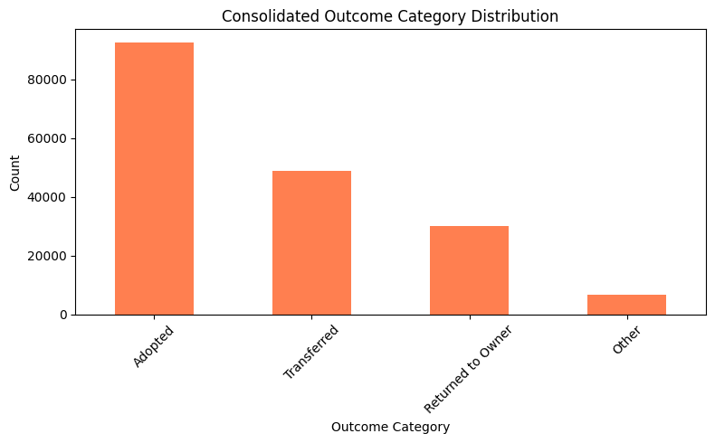
The Consolidated Outcome Category Distribution bar chart established the baseline context for the entire analysis by showing that adoption is the most common outcome at 52%. This directly supports the shelter's strong commitment to live release while also making visible the smaller but meaningful proportion of animals in the Other category. This chart was produced using matplotlib and set the foundation for all subsequent visualizations.
Figure 1. Consolidated Outcome Category Distribution
The Outcome Category by Animal Type grouped bar chart introduced the first key finding—that dogs and cats experience meaningfully different outcome patterns, particularly in the Returned to Owner and Transferred categories. Produced using seaborn's countplot function, this chart uses color coding to distinguish species, making species comparisons immediately intuitive
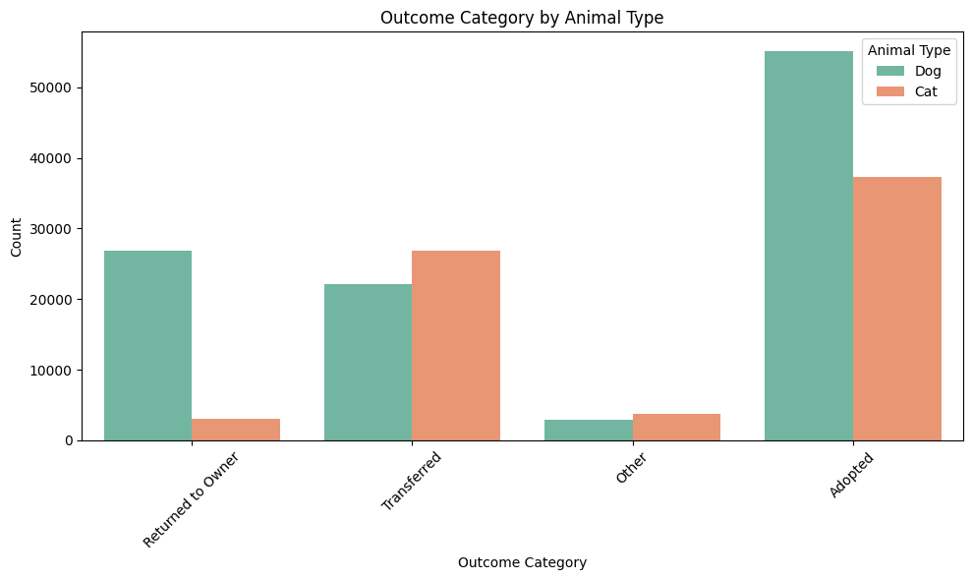
Figure 2. Outcome Category by Animal Type

The Outcome Category by Intake Type grouped bar chart demonstrated the strong relationship between how an animal entered the shelter and what happened to it, with stray animals showing the highest adoption volumes. This visualization supported the intake type as a meaningful predictor variable and was produced using seaborn.
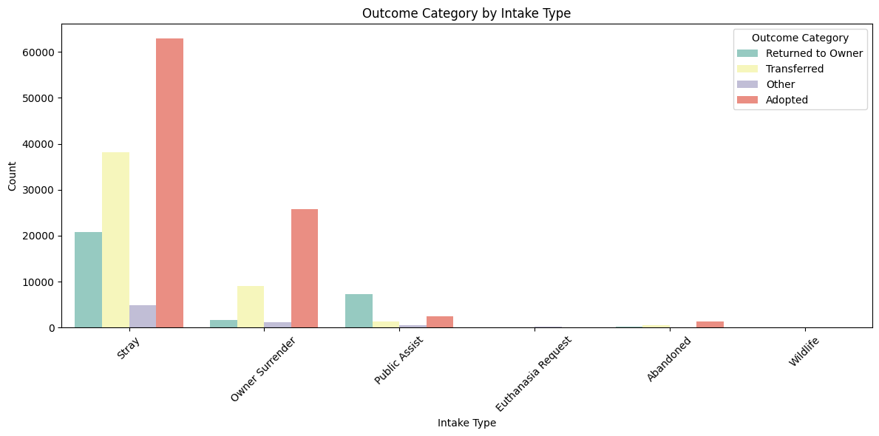
Figure 3. Outcome Category by Intake Type

The Length of Stay by Outcome Category box plot showed one of the project's most important findings—that animals returned to their owners and were transferred out of the shelter the fastest. In contrast, adopted animals show the widest range of stay lengths. Box plots were selected because they effectively display the full distribution of a continuous variable, including median, quartiles, and outliers, making the differences between outcome categories immediately apparent.
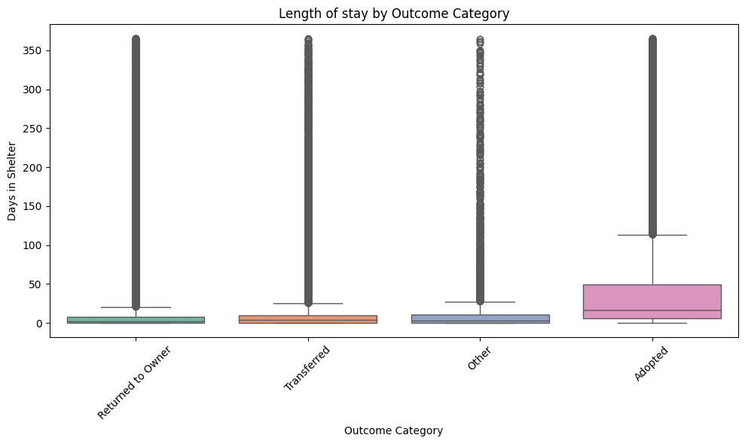
Figure 4. Length of Stay by Outcome Category

The Outcome by Intake Condition grouped bar chart showed that the vast majority of animals arrive in normal condition. That intake condition influences the distribution of outcomes, supporting its inclusion as a predictor variable. This chart was produced using seaborn.
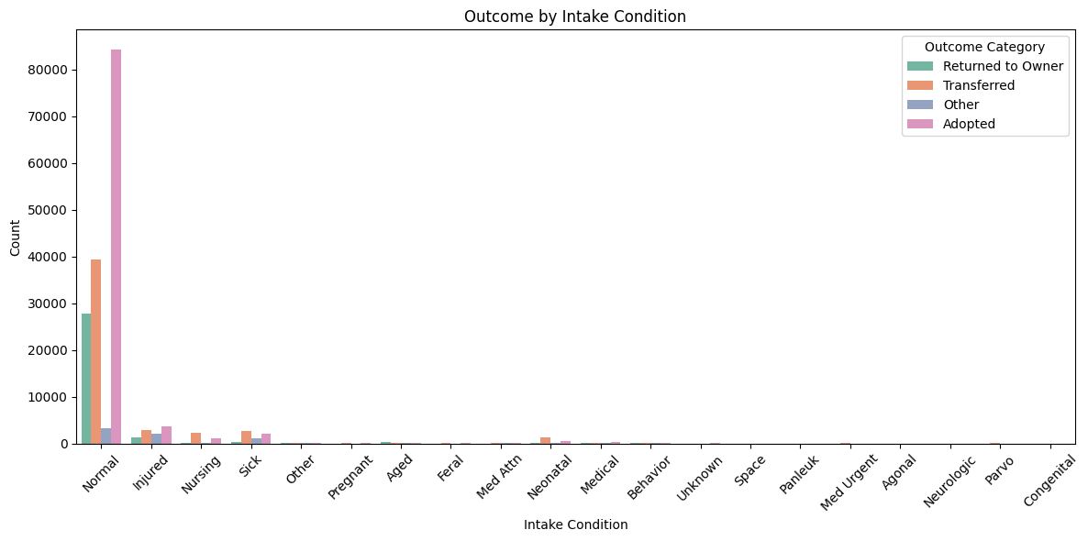

Figure 5. Outcome by Intake Condition

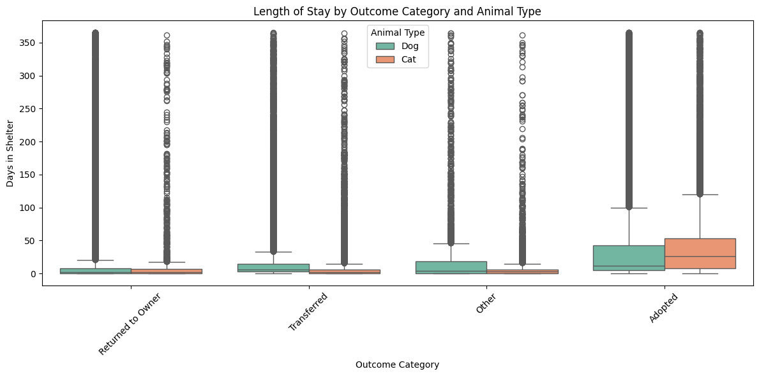
The Length of Stay by Outcome Category and Animal Type box plot extended the length-of-stay analysis by adding species as a grouping variable, revealing that cats consistently leave the shelter more quickly than dogs across almost every outcome category. This visualization deepened the species-level story established in the second chart and was produced using seaborn.
Figure 6. Length of Stay by Outcome Category and Animal Type

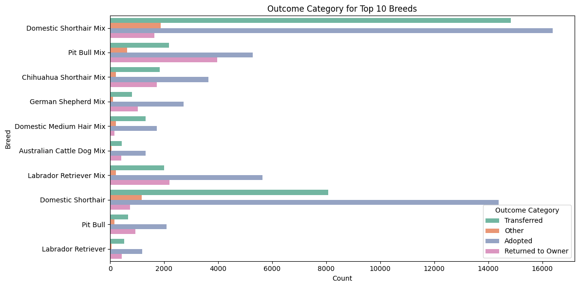
The Outcome Category for Top 10 Breeds horizontal bar chart highlighted breed-level differences in outcomes, particularly the higher transfer rates for Domestic Shorthair Mix cats and the lower adoption rates relative to transfers for bully-type breeds. Produced using seaborn, this chart used a horizontal orientation to accommodate the longer breed name labels and make them readable.
Figure 7. Outcome Category for Top 10 Breeds

The Feature Importance horizontal bar chart was the project's headline visualization, presenting the ranked importance scores for all 9 predictor variables in a single, clear image. Produced using matplotlib, this chart directly answers the research question by showing which animal characteristics most strongly predicted adoption outcomes, with length of stay clearly dominant at 30%. This visualization served as the anchor for the project's recommendations and conclusions.
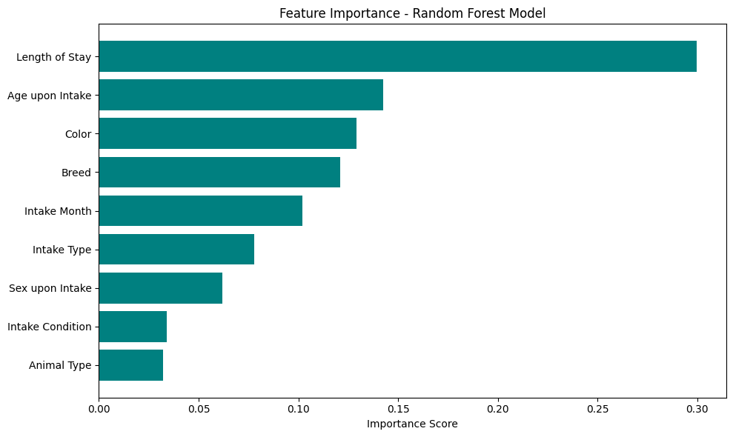

Figure 8. Feature Importance - Random Forest Model

Together, these eight visualizations told a coherent data story—from overall outcome patterns to species and intake differences, to the critical role of length of stay and the surprising influence of coat color—that builds logically toward the feature importance findings and the actionable recommendations that follow.

G.3 Recommended Courses of Action
Based on this analysis, two courses of action are recommended for the Austin Animal Center.
Recommendation 1 — Implement a Length of Stay Early Intervention Program
The strongest finding of this project was that length of stay is the most powerful predictor of adoption outcomes, with adoption odds declining sharply after the first week of shelter stay. The Austin Animal Center should implement a structured early intervention program that automatically flags animals after seven days in the shelter for targeted action. Flagged animals should be prioritized for foster placement referrals, increased social media promotion, inclusion in adoption events, and behavioral enrichment programs designed to reduce stress-related behavioral issues that may hinder adoption. Research shows that shelters implementing targeted intervention programs achieve higher live-release rates and lower return rates, even under significant resource constraints (Reese, 2021), supporting the feasibility of this recommendation for a large municipal shelter like the Austin Animal Center.
Recommendation 2 — Develop Targeted Adoption Initiatives for High-Risk Animal Profiles
The feature importance results identified age (2nd), color (3rd), and breed (4th) as the strongest predictors of adoption outcomes. The Austin Animal Center should develop targeted adoption initiatives specifically designed to address the adoption barriers associated with these characteristics. For age, a senior pet adoption program offering reduced fees or special promotions for dogs and cats over 5 years old would directly address the lower adoption odds faced by older animals. For color, improvements to shelter photography practices—including better lighting, higher-contrast backgrounds, and guidelines for photographing dark-coated animals—combined with targeted social media campaigns that emphasize individual personality over appearance, would help counteract the coat-color bias identified in both this project's model results and published research. For breed, removing or deprioritizing breed labels for mixed-breed dogs in favor of behavioral descriptions would help reduce breed-based adoption bias, particularly for bully-type breeds, a strategy shown to improve live-release rates in shelters across the United States.
Both recommendations directly address the organizational need identified in this project, helping administrators use data-driven insights to prioritize limited resources toward at-risk animals and improve the Austin Animal Center's live release rate.

H Panopto Presentation
Rubric H: A link to a Panopto recording is provided, and the summary includes each of the given elements. The summary is appropriate for a data analytics peer audience.
Provide a link to your Panopto video.
- You are required to use Panopto, and you need to first request access, Panopto Access. Gaining permission may take up to 48 hours.
- Your recording should include your voice, but showing your face is not required. If you need special accommodations, please contact Assessment Services and alert your assigned course faculty.
- There is no minimum length, but it is not meant to be long. Depending on your project, approximately 5-15 minutes is a good length.
The video should provide the viewer with a bird’s-eye view of your project and how you conducted your analysis. Here are the points you should cover:
- A summary of your research question or organizational need.
- A summary demonstration of the functionality of any code you used for your data analytics solution.
- An outline of the findings and implications of your analysis.
The video should summarize your question and findings. You can think of this as a “water cooler” version of your report. The evaluator should be able to watch the video and understand your project’s purpose and main argument. Then, for step 2, bring your code (or software analysis) on screen and step through how you conducted your analysis. Unfortunately, we don’t have an example video. However, I never see the video rejected unless it’s missing step 2 above.

Works Cited
Jardim, R., Colaco, B., Lurdes Pinto, M. d., & Alves-Pimenta, S. (2026, January 4). Trends in Intake, Length of Stay, and Outcome Data in a Portuguese Animal Shelter Between 2018 and 2024. (M. Herron, Ed.) Animals, 16(1). doi:https://doi.org/10.3390/ani16010141
Parte, S. (2019). Predicting the Hosting Animal Center Outcome Based on Supervised Machine Learning Models. MSc Research Project-- National College of Ireland, 1-22. Retrieved from https://norma.ncirl.ie/4292/1/sushantprabhatparte.pdf
Powell, L., Reinhard, C., Satriale, D., Morris, M., Serpell, J., & Watson, B. (2021, April 13). Characterizing unsuccessful animal adoptions: Age and breed predict the likelihood of return, reasons for return and post-return outcomes. Scientific Reports, 11(1). doi:https://doi.org/10.1038/s41598-021-87649-2
Reese, L. (2021). Shelter and rescue programmes associated with higher live release and lower return rates for dogs. Animal Welfare: the International Journal of Animal Welfare Science, 30(4), 419-430. doi:https://doi.org/10.7120/09627286.30.4.005
Schroer, C., Kruse, F., & Gomez, J. M. (2021). A Systematic Literature Review on Applying CRISP-DM Process Model. Procedia Computer Science, 181, 526-534. Retrieved from https://www.sciencedirect.com/science/article/pii/S1877050921002416
Svoboda & Hoffman. (2015, November). Investigating the role of coat colour, age, sex, and breed on outcomes for dogs at two animal shelters in the United States. Animal Welfare. (U. a. Dr Birte Nielsen Universities Federation for Animal Welfare, Ed.) Animal Welfare : The international journal of animal welfare science, 24(4), 497-506. doi:https://doi.org/10.7120/09627286.24.4.497
Villarreal, J. A., Gebauer, R., & Ha, J. C. (2026, January 4). Do Black Cats Look Less Adoptable? Human Judgements of Emotions and Adoptability in Online Shelter Photographs in the United States. Animals, 16(6). doi: https://doi.org/10.3390/ani16060869

Appendix A

Project Code
The complete Python code used for this project is available at the following GitHub repository:
https://github.com/hstuken-oss/capstone-predicting-adoption-outcomes
A fully rendered version of the Jupyter Notebook including all code outputs and visualizations can be viewed at: https://nbviewer.org/github/hstuken-oss/capstone-predicting-adoption-outcomes/blob/main/capstone.ipynb

Appendix B

Data Sources
The Austin Animal Center Intakes and Outcomes datasets used in this project are publicly available through the City of Austin Open Data Portal:
- Intakes: https://data.austintexas.gov/Health-and-Community-Services/Austin-Animal-Center-Intakes/wter-evkm
- Outcomes: https://data.austintexas.gov/Health-and-Community-Services/Austin-Animal-Center-Outcomes/9t4d-g238

